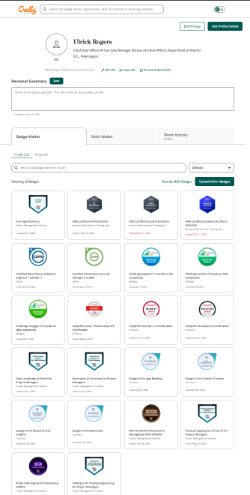
https://www.credly.com/users/ulrick-maurice-rogers

